## Lab 5 – Theory questions

Please submit your answers to the following questions on paper.

1. Describe what a ‘process’ is.

**A process is a program in execution and it requires resources, which are managed by the operating system.**

1. What impact does a process have on the systems hardware?

* **Loaded at boot time and initializes system**
* **Creates initial system processes**
* **Remains in memory and manages the system**

3. Explain the following from the screen shot below.

1. PID: **The ID number used to identify a running process.**
2. %CPU: **It shows the percentage of CPU usage on a task with different categories.**
3. %MEM: **It shows the percentage of memory used and free with the consumption rate of each account.**
4. COMMAND: **Name of the command the user is currently running.**

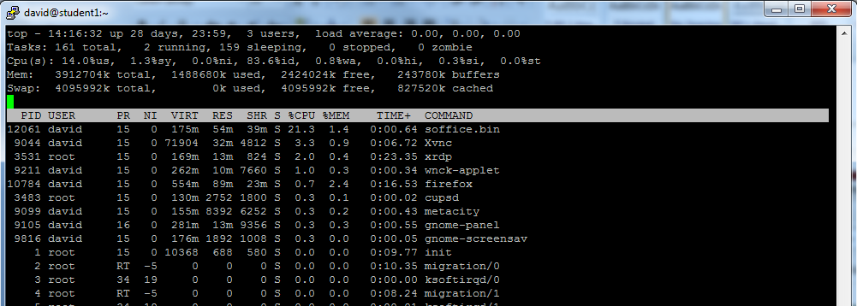

4. If a command was taking a large amount of system resources (memory and processing) and this was causing some system performance issues, what could a system administrator do to solve the problem?

**The user can use the kill command to completely kill the process, or they can use the sleep command to delay process for a specified amount of time.**